## Power BI Sales Analytics Dashboard – Awesome Chocolates

**Calculated Columns**

Calculating Cost: Cost per box is available in “Product” Table. No of boxes in shipments Table. How Cost per sale is calculated in the Shipments Table is shown below.

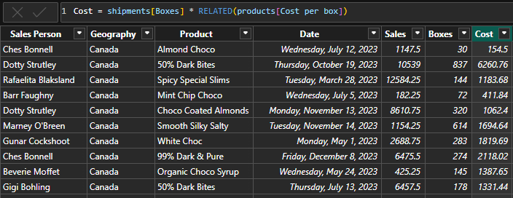

**Field** **Parameters**

Field Parameters were created to use in a slicer to dynamically change results in the visual. This allows us to show multiple findings in a single visual.

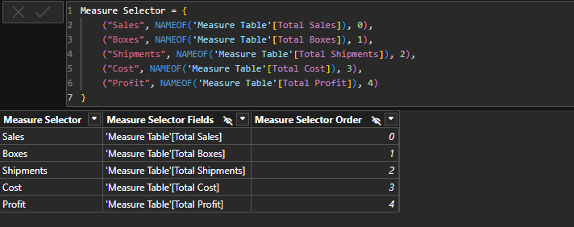

**Bins**

Bins are useful to create a histogram. “Boxes” column was grouped into bins of size 20. This helps to find the Box range and their count. Low box shipment ranges can be found using this method.

